Chapter 15, Problem 37.

Find the inverse Laplace transform of:

(a) 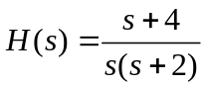
(b) 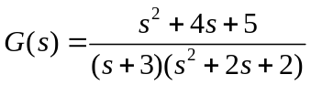
(c ) 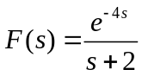
(d) 